**DEVELOPMENT OF WEBSITE FOR GITAM (Hyderabad)**

Agenda for the application:

The following Application is useful to provide the basic information about GITAM university Hyderabad campus .

* To get the feedback from the people
* To make people to sign on to their website
* To provide several facilities regarding there institution to others by giving access to people by their login page.

Data to be captured:

1. Name
2. Phone number
3. Email id
4. Date of birth
5. Branch
6. Roll number
7. Year of admission
8. College ID number

**Uml Diagrams:**

**Class diagram:**

The class diagram is the main building block of object-oriented modelling. It is used for general conceptual modelling of the structure of the application, and for detailed modelling translating the models into programming code. Class diagrams can also be used for data modelling. The classes in a class diagram represent both the main elements, interactions in the application, and the classes to be programmed.

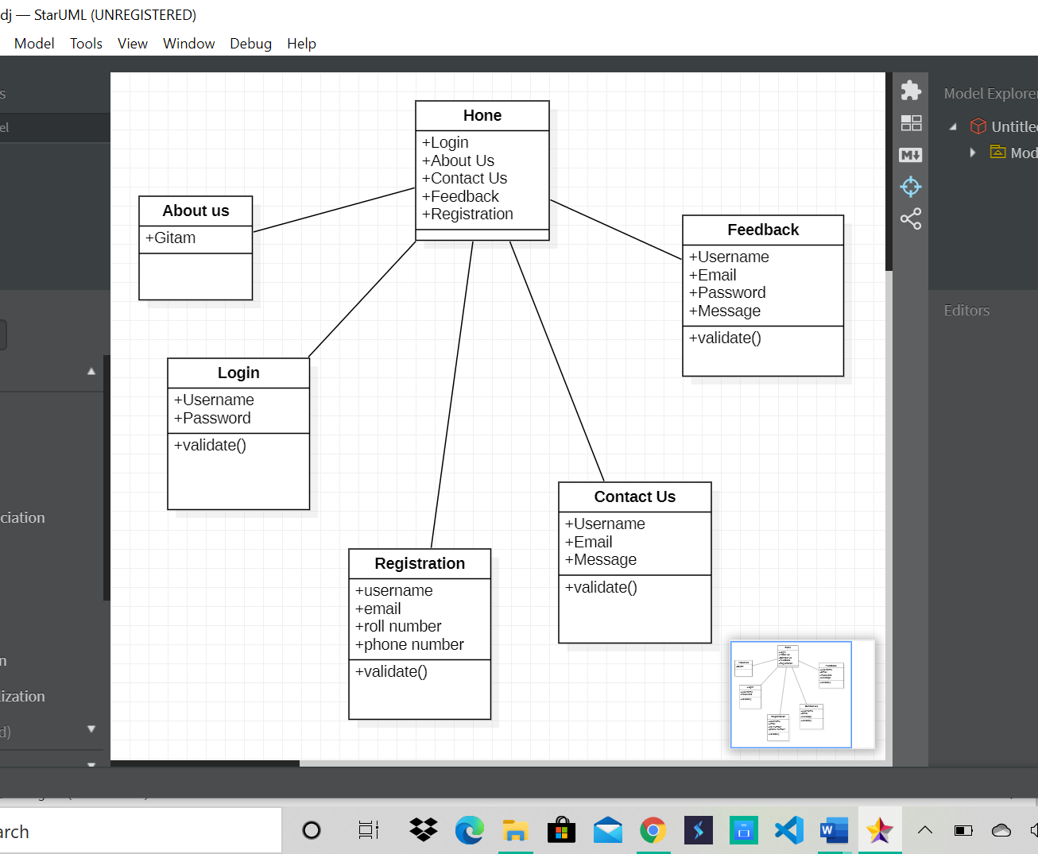

**Classes in above diagram are:**

1. Home
2. About
3. Login
4. Contact us
5. Feedback
6. Registration

**Use Case Diagram:**

A **use case diagram** at its simplest is a representation of a user's interaction with the system that shows the relationship between the user and the different [use cases](https://en.wikipedia.org/wiki/Use_case) in which the user is involved. A use case diagram can identify the different types of users of a system and the different use cases and will often be accompanied by other types of diagrams as well. The use cases are represented by either circles or ellipses.

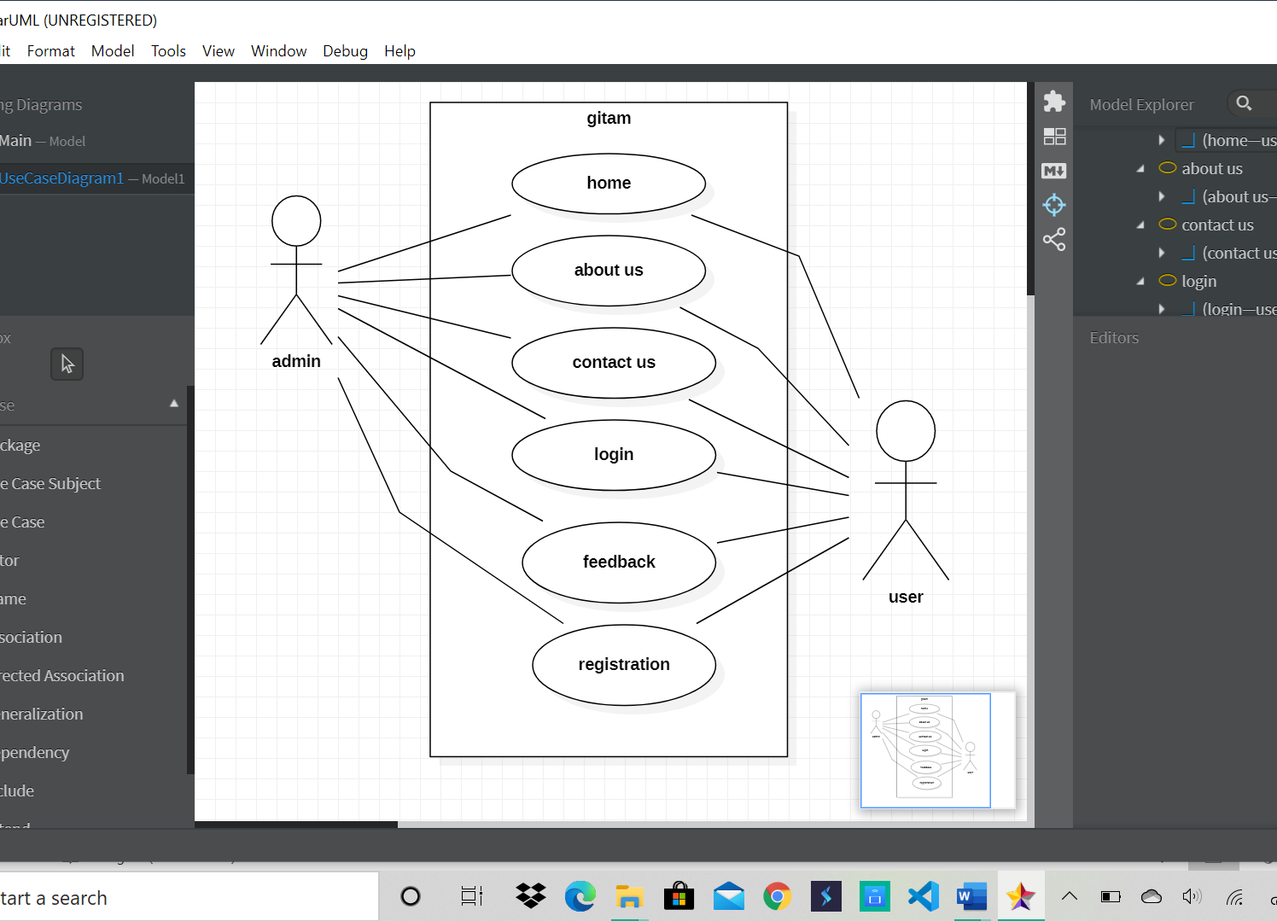

**Use Cases in above diagram are:**

1. Home
2. About
3. Login
4. Contact us
5. Feedback
6. Registration

**Actors in the above Diagram are:**

1. **Admin**
2. **Student**

**Wireframes:**

A wireframe is a schematic or blueprint that is useful for helping you, your programmers and designers think and communicate about the structure of the software or website you're building .The following wireframe is having a title and image bars at the tops and we have a nav bar at the bottom of it where it has several sub- pages like about, home, login, feedback, registration, contact us pages.

